**PROJECT**

**REPORT**

|  |  |
| --- | --- |
| PROJECT NAME | GAS LEAKAGE MONITORING &  ALERTING SYSTEM FOR INDUSTRIES |
| TEAM ID | PNT2022TMID09616 |
| TEAM MEMBERS | GIRIDHARAN P (310619205030)  AKSHAY RAM RB (310619205007)  KARTHIKEYAN S (310619205045)  ETHIRAJ M (310619205026) |
| BRANCH | INFORMATION TECHNOLOGY |

1. **INTRODUCTION**
   1. **Project Overview:**

The internet of Things is a developing topic of technical, social, and economic significance. The usage of the gas brings great problems in the domestic as well as working places. The inflammable gas, which is excessively used in the work places (Industries). The leakage of the gas causes destructible impact to the lives and as well as to the heritage of the people. Most of the societies have fire safety mechanism. But it can use after the fire exists. As a result, a system for detecting and monitoring gas leaks is required. Through a flame sensor, the system will sense fire and flame. The buzzer begins to ring when a fire is detected. Tests have shown that the system can keep track of the wastage of gas and leaks and notify the user. The performance that was produced showed that it was successful in reducing the amount of gas that was wasted.

* 1. **Purpose:**

The design of a sensor-based automatic gas leakage detector with an alert and control system has been proposed. This is an affordable, less power using, lightweight, portable, safe, user friendly, efficient, multi featured and simple system device for detecting gas. To monitor this gas leak, the system includes an MQ6 gas detector. This sensor detects the amount of leaking gas present in the surrounding atmosphere. In this way, the consequences of an explosion or gas leak can be avoided.

1. **LITERATURE SURVEY :**
   1. **Existing Problem:**

Gas leakage is nothing but the leak of any gaseous molecule from a pipeline, or cylinder etc in the industries. Gas Leakages in open or closed areas can prove to be dangerous .This can occur either purposefully or even unintendedly. As we are aware that these kinds of leaks are dangerous to our health, and when it becomes explosive it could cause great danger to the people, industry and the environment. Therefore, we have used IoT technology to make a Gas Leakage Detector for society which has Smart Alerting techniques involving sending a text message to the concerned authority and the ability to perform data analytics on sensor readings. Our main aim is to propose a gas leakage system for a society where each flat has gas leakage detector hardware. This will detect the harmful gases in the environment and alerting to society members through the alarm and sending notifications.

* 1. **References:**
     1. Shital Imade, Priyanka Rajmanes, Aishwarya Gavali , Prof. V. N. Nayakwadi “GAS

LEAKAGE DETECTION AND SMART ALERTING SYSTEM USING IOT”

<https://www.pramanaresearch.org/gallery/22.%20feb%20ijirs%20-%20d539.pdf>

* + 1. Kumar Keshamoni and Sabbani Hemanth. "Smart Gas Level Monitoring, Booking

& Gas Leakage Detector over IoT " International Advance Computing Conference IEEE, 2017.

* + 1. Petros Spachos , Liang Song and Dimitrios Hatzinakos. "Gas Leak Detection and

Localization System Through Wireless Sensor Networks" The 11th Annual IEEE Consumer Communications and Networking Conference - Demos. IEEE, 2014.

* + 1. “Design and Implementation of an Economic Gas Leakage Detector” National

Institute of Health (2004). What you need to know about natural gas detectors. Av[ailable:http:/](http://www.nidcd.nih.gov/health/smelltaste/gas)/www[.nidcd.nih.gov/health/smelltaste/gas d](http://www.nidcd.nih.gov/health/smelltaste/gas)tctr.asp.

* + 1. Prof.M.Amsaveni, A.Anurupa, R.S.Anu Preetha, C.Malarvizhi,M.Gunasekaran

“Gsm based LPG leakage detection and controlling system” the International

Journal of Engineering and Science (IJES) ISSN (e): 2319 – 1813 ISSN (p):2319 – 1805 Pages 112-116 March- 2015.

* + 1. Srinivasan,Leela,Jeyabharathi,Kirthika,Rajasree“GAS LEAKAGE DETECTION AND CONTROL” Scientific Journal of Impact Factor(SJIF): 3.134.
    2. Pal-Stefan Murvaya, IoanSileaa “A survey on gas leak detection and localization techniques”.
    3. Ch. Manohar Raju, N. Sushma Rani, “An android based automatic gas detection and indication robot. In International Journal of Computer Engineering and Applications. 2014;8(1).
    4. Falohun A.S., Oke A.O., Abolaji B.M. “Dangerous Gas Detection using an

Integrated Circuit and MQ-9” in International Journal of Computer Applications (0975 –8887) Volume 135 – No.7, February 2016.

* + 1. Ashish Shrivastava,Ratnesh Prabhaker, Rajeev Kumar and Rahul Verma “GSM

BASED GAS LEAKAGE DETECTION SYSTEM” in International Journal of Technical

Research and Applications e-ISSN: 2320- [8163,www.](http://www.ijtra.com/)ijtr[a.com V](http://www.ijtra.com/)olume 1, Issue 2 (may-June 2013).

* + 1. C.Selvapriya, S.Sathyaprabha, M.Abdulrahim,” LPG leakage monitoring and multilevel alerting system”, published in 2013.
    2. Falohun A.S., Oke A.O., Abolaji B.M. “Dangerous gas detection using an integrated circuit and MQ-9. In International Journal of Computer Applications. 2016; 135(7).
  1. **Problem Statement Definition:**

In most industries, one of the key parts of any safety plan for reducing risks to personnel and plant is the use of early-warning devices such as gas detectors. These can help to provide more time in which to take remedial or protective action. They can also be used as part of a total, integrated monitoring and safety system for an industrial plant. Rapid expansion of oil and gas industry leads to gas leakage incidents which are very serious and dangerous. Solutions need to be found out at least to minimize the effects of these incidents since gas leaks also produce a significant financial loss. The challenges are not only to design a prototype of the device that can only detect but also automatically respond to it whenever the leakage occurs.

1. **IDEATION & PROPOSED SOLUTION:**
   1. **Empathy Map Canvas:**

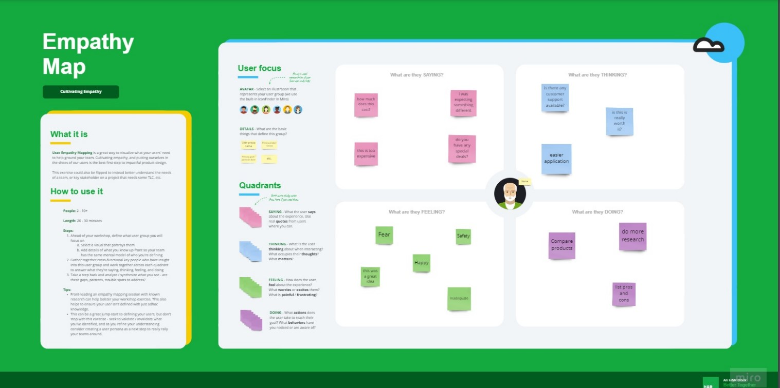

* 1. **Ideation & Brainstorming:**

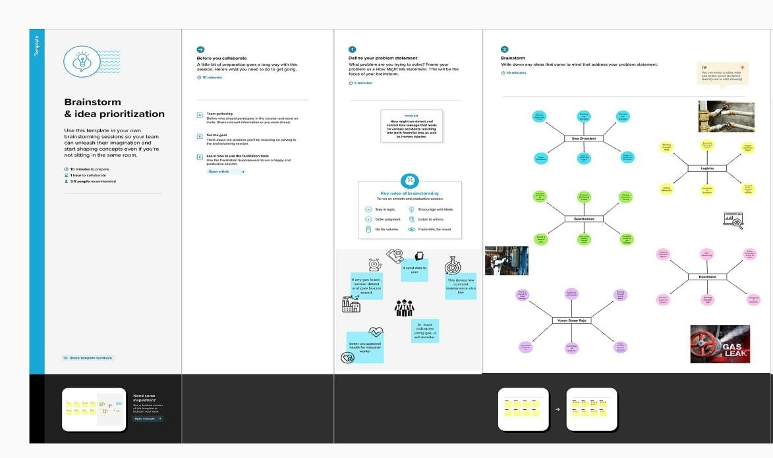

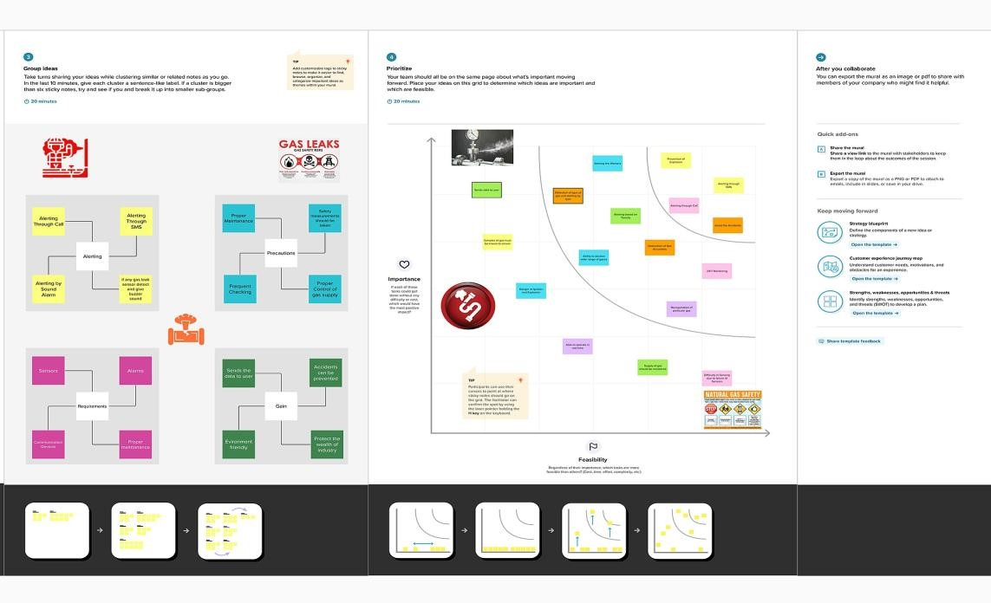

* 1. **Proposed Solution:**

|  |  |  |
| --- | --- | --- |
| S.No | Parameter | Description |
| 1. | Problem Statement (Problem to be solved) | Gas leakage leads to various accidents resulting in loss of human lives and industry properties. Sometimes, the gas leakage cannot be detected by human that has a low sense of smell. Thus, this system will help to detect the presence of gas leakage and alert the users. |
| 2. | Idea / Solution description | It detects the gas leakage by using various sensors. If the gas leakage level is above the threshold level, it sends the alert message through SMS to the user by using GSM module and buzzer the alarm. |
| 3. | Novelty / Uniqueness | We use location tagging and alert service so that the admin and fire department team will be notified the exact location. The system provides constant monitoring and detection of gas leakage along with storage of data in database for predictions and analysis. |
| 4. | Social Impact / Customer  Satisfaction | By implementing real-time gas leak detection, industries can monitor their environmental performance, ensure better occupational health. Also, early detection of gas leaks can trigger concerned engineers to curtail the spread and keep a safe environment for better health and safety. |
| 5. | Business Model (Revenue  Model) | The product can be made compact, cost efficient and easily installable so that all the  industries from small scale to large scale can able to buy the product . |
| 6. | Scalability of the Solution | The system is very simple and easy to maintain and cost efficient. It has the capability to works for a period of time without any damage in the system components. |

* 1. **Problem Solution fit:**

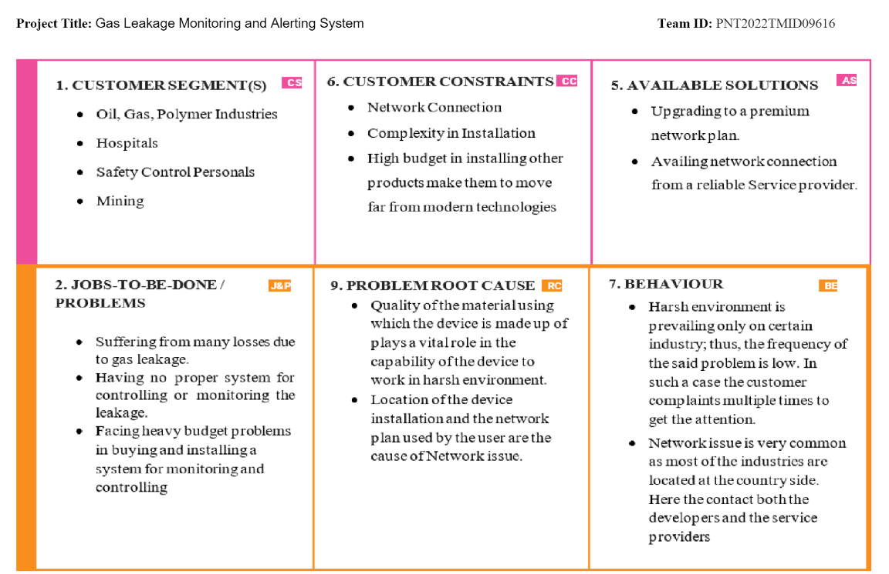

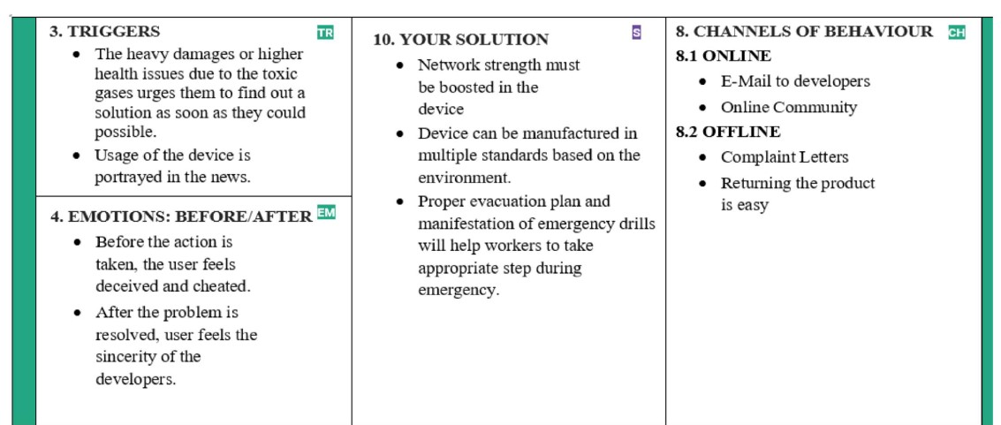

1. **REQUIREMENT ANALYSIS:** 
   1. **Functional requirement:**

|  |  |  |
| --- | --- | --- |
| FR No. | Functional Requirement  (Epic) | Sub Requirement (Story / Sub-Task) |
| FR-1 | User Registration | Registration through Form Registration through Gmail  Registration through LinkedIN |
| FR-2 | User Confirmation | Confirmation via Email  Confirmation via OTP |
| FR-3 | GPS Access | GPS access to know the location |
| FR-4 | Business Requirements | The device is intended for the use of industries or factories and also for cylinder storage areas. It detects the leakage of gas and sends the data over to a site and preventive measures can be taken to avoid the loss of properties. |
| FR-5 | User Requirements | The Gas leakage detecting system with upgrading technologies which identifies the leakage of gas and also ensures the workers safety. |

* 1. **Non-Functional requirements:**

|  |  |  |
| --- | --- | --- |
| FR No. | Non-Functional Requirement | Description |
| NFR-1 | Usability | The sensors used to detect the gas leakage which helps to prevent the high risk of gas explosion and also can prevent the causalities within and outside the covering area of the industries. |
| NFR-2 | Security | The device is intended for the use of industries or factories, where there is a use of explosive gas is a source of risk. This device will help and secures from the causes. |
| NFR-3 | Reliability | Gas leakage detecting system detects the gas leakage at industries or factories which detects the small amount of gas leakage as soon and sends the alerting SMS to users. |
| NFR-4 | Performance | The Gas leakage detecting system is a device with an alarm setting. Whenever there is a gas leak ,which is greater than the threshold level, the in- build sensor detects and alerts the user within a minute much before it can cause any accidents. |
| NFR-5 | Availability | The gas leakage detecting system is readily available in the market which is extremely expensive, but here we are providing a low-cost circuit for gas leakage detecting system and also it is user friendly |
| NFR-6 | Scalability | The system is very simple and easy to maintain with cost efficient. A backup power supply will be included in the design to prevent from the power failure conditions. It has the capability to works for a period of time without any damage in the system components. |

1. **PROJECT DESIGN:** 
   1. **Data Flow Diagrams:**

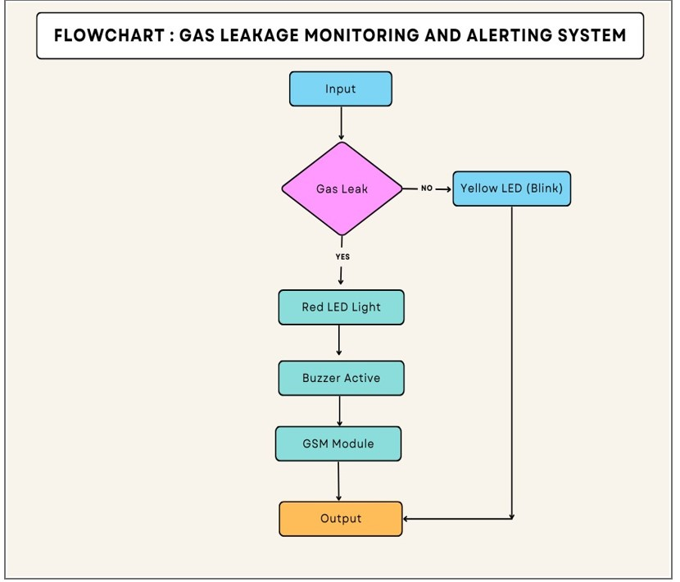

* 1. **Solution & Technical Architecture:**

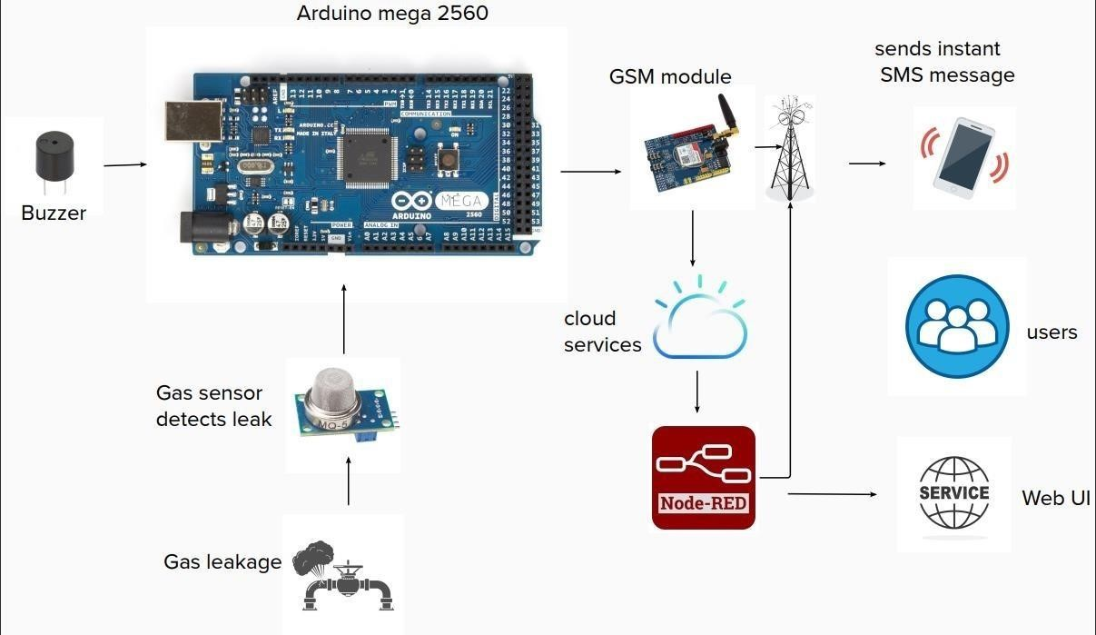

* 1. **User Stories:**

|  |  |  |  |  |  |  |
| --- | --- | --- | --- | --- | --- | --- |
| User Type | Functional  Requirement  (Epic) | User  Story  Number | User Story /  Task | Acceptance criteria | Priority | Release |
| Customer  (Mobile user) | Registration | USN-1 | As a user, I can create an account in the application provided. | I can access my account/ dashboard | High | Sprint-1 |
|  |  | USN-2 | As a user, I registered using my Gmail. | I can receive confirmation email. | High | Sprint-1 |
|  |  | USN-3 | As a user, I can successfully install the app. | I can register and access the dashboard. | Low | Sprint-2 |
|  | Login | USN-4 | As a user, I can login using my Gmail and password easily. | The login process was easy and simple to access the dashboard. | High | Sprint-1 |
| Customer  (Web user) | Registration | WUSN-1 | As a web user I can login to web dashboard just like a website. | I can register and access the dashboard. | High | Sprint-2 |
|  | Dashboard | WUSN-2 | As a user I can view the alert/warning SMS in the web application. | I can login to the website using my login credentials | High | Sprint-2 |
| Customer Care  Executive |  | CCE-1 | A customer care executive will always be available for the interaction with the customer to clarify the queries. | An executive will clarify the doubts and note down the complaints of the application if any. | High | Sprint-2 |
| Administrator |  | ADMIN-1 | I as an Admin can access and view the data or information provided by the application &can also check, analyse the threshold value of the gas. | The details of the gas leakage level of the gas are provided to the users through SMS when an  alerting sound is received. | High | Sprint-1 |

1. **PROJECT PLANNING & SCHEDULING:** 
   1. **Sprint Planning & Estimation:** 
      * + SPRINT PLAN
        + ANALYZE THE PROBLEM
        + PREPARE an ABSTRACT, PROBLEM STATEMENT
        + LIST A REQUIRED OBJECT NEEDED
        + CREATE A PROGRAM CODE AND RUN IT
        + MAKE A PROTOTYPE TO IMPLEMENT
        + TEST WITH THE CREATED CODE AND CHECK THE DESIGNED PROTOTYPE
   2. **Sprint Delivery Schedule:**

|  |  |  |  |  |  |
| --- | --- | --- | --- | --- | --- |
| Sprint | Functional  Requirement  (Epic) | User  Story | User Story / Task | Story  Point | Priority |
| Sprint-1 | Create | US-1 | Create the IBM Cloud services which are being used in this project. | 5 | High |
| Sprint-1 | Configure | US-2 | Configure the IBM Cloud services which are being used in completing this project. | 1 | Medium |
| Sprint-1 | Create | US-3 | IBM Watson IoT platform acts as the mediator to connect the web application to IoT devices, so create the IBM  Watson IoT platform. | 1 | Medium |
| Sprint-1 | Configure | US-4 | Configure the IBM Watson IoT which are being used to display the output. | 13 | High |
| Sprint-2 | Create | US-1 | In order to connect the IoT device to the IBM cloud, create a device in the IBM Watson IoT platform and get the device credentials. | 13 | High |

|  |  |  |  |  |  |
| --- | --- | --- | --- | --- | --- |
| Sprint-2 | Configure | US-2 | Configure a device in the IBM Watson IoT platform and get the device credentials. | 3 | Medium |
| Sprint-2 | Create | US-3 | Create a Node-RED service. | 3 | High |
| Sprint-2 | Configure | US-4 | Configure the connection security  and create API keys that are used in the  Node- RED service for accessing the  IBM IoT Platform. | 1 | Medium |
| Sprint-3 | Develop | US-1 | Develop a python script to publish  random sensor data such as  temperature, Flame  level and Gas level to the IBM  IoTplatform | 1  3 | High |
| Sprint-3 | Configure | US-2 | After developing python code and commands just run the code | 1 | Medium |
| Sprint-3 | Print | US-3 | Print the statements which represent the  control of the devices. | 1 | Low |
| Sprint-3 | Publish | US-4 | Publish Data to  The IBM  Cloud | 5 | High |
| Sprint-4 | Create | US-1 | Create Web UI in  Node- Red | 5 | High |
| Sprint-4 | Configure | US-2 | Configure the Node-  RED flow to receive data from the  IBMIoT platform | 5 | High |
| Sprint-4 | Configure | US-3 | Use cloudant DB nodes to store the received sensor data in the  cloudant DB | 5 | High |
| Sprint-4 | Publish | US-4 | Publish the received data inweb- application | 5 | High |

* 1. **Report from JIRA:**

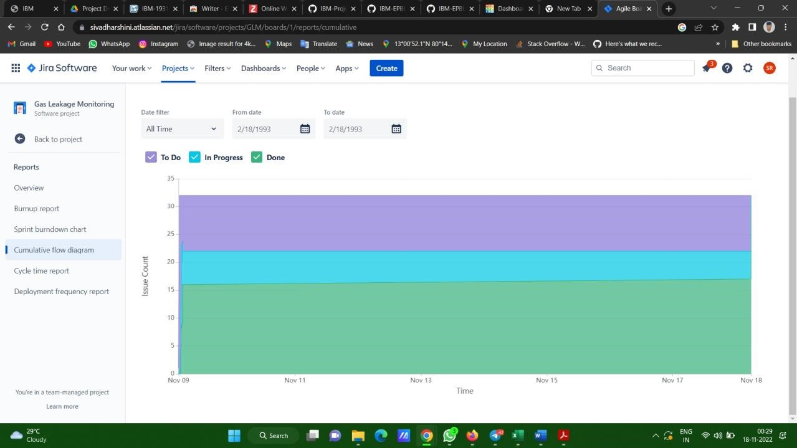

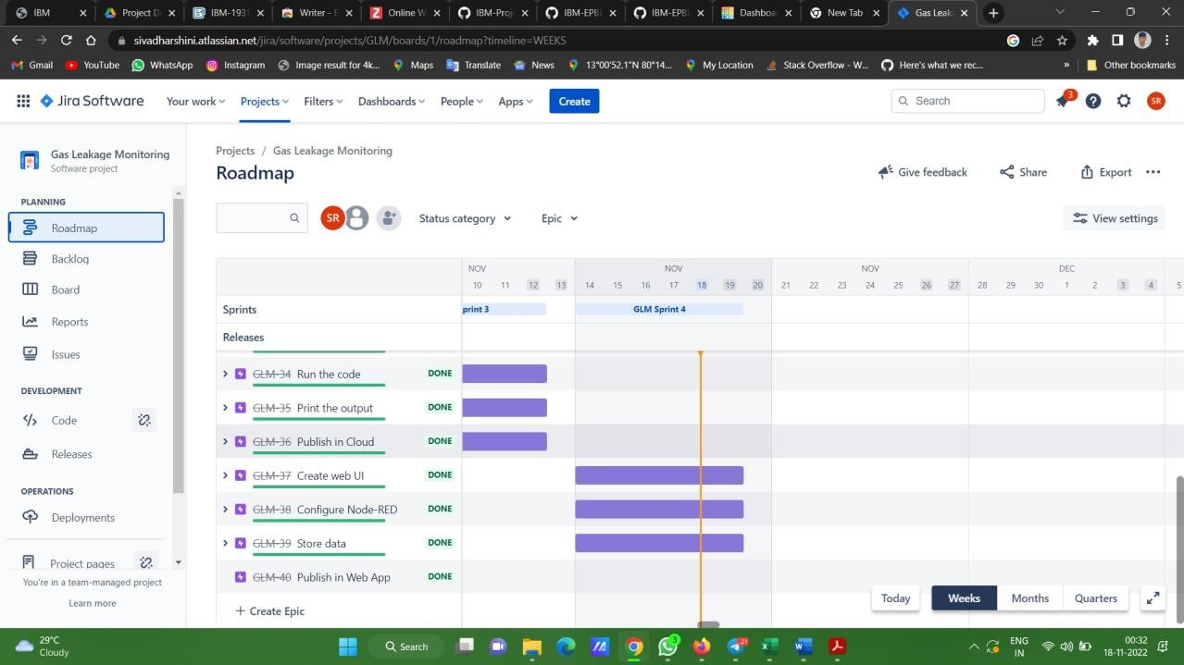

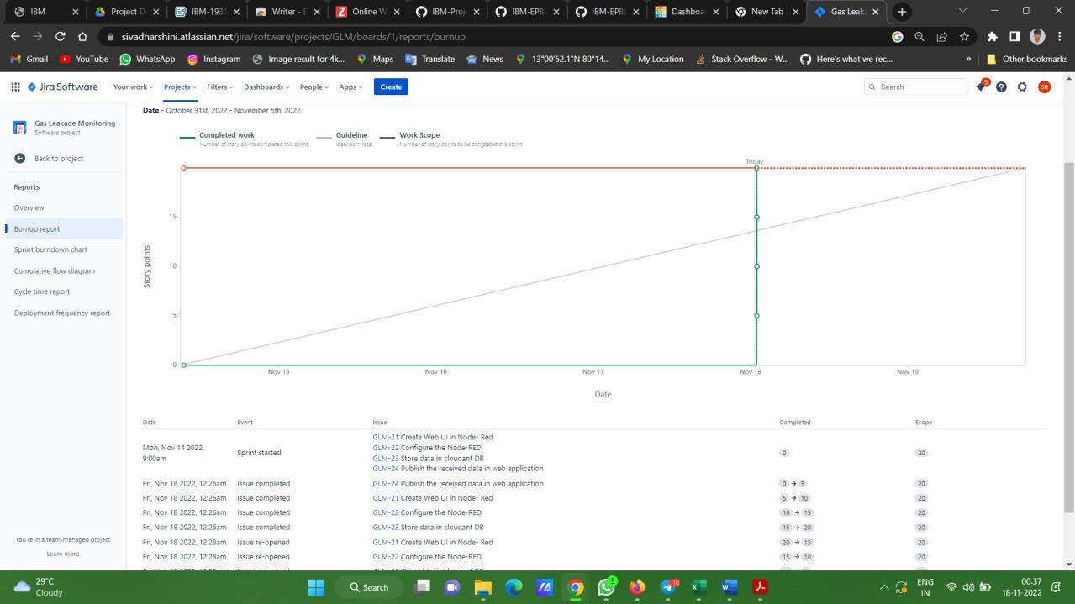

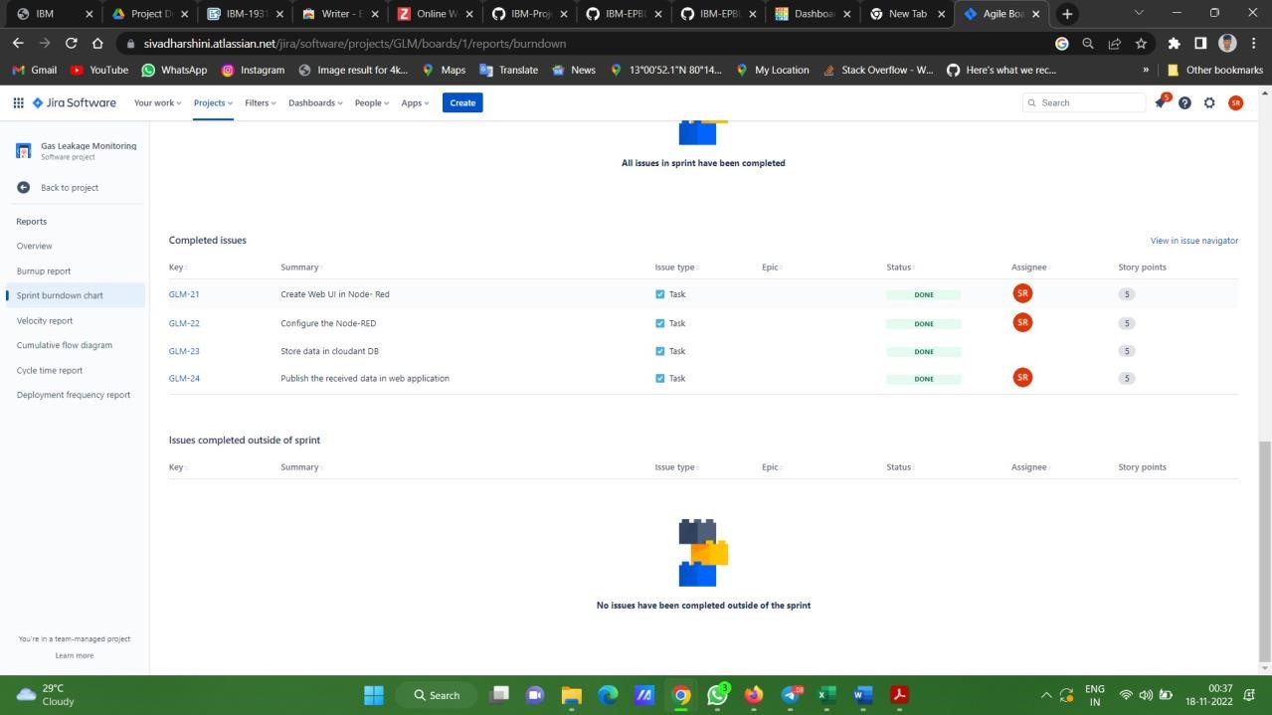

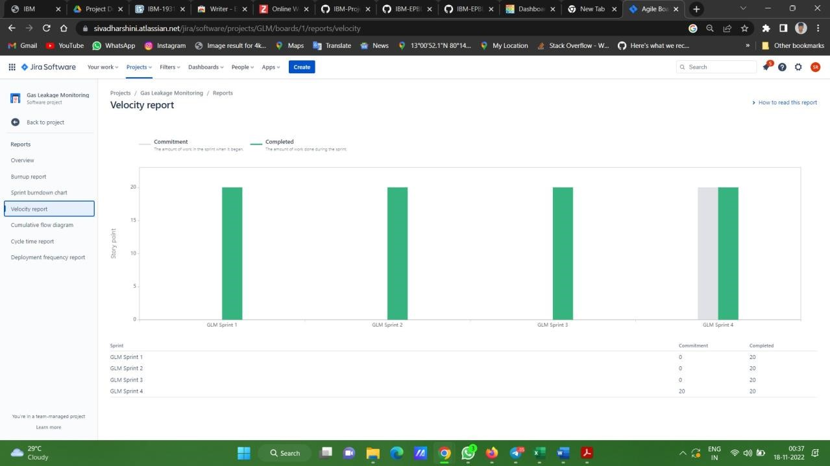

1. **CODING & SOLUTIONING:**

# Importing Required modules import time import sys

import wiotp.sdk.device# IBM IoT Watson Platform Module import ibmiotf.device import tkinter as tk # Python GUI Package from tkinter import ttk # Python GUI import time

from threading import Thread

organization = "0tus0f" # Organization ID deviceType = "ESP32" # Device type deviceId = "01" # Device ID authMethod = "token" # Authentication Method authToken = "Gowth@m@nk18" #Replace the authtoken

# Tkinter root window root = tk.Tk() root.geometry('350x300') # Set size of root window root.resizable(False, False) # root window non-resizable

root.title('Gas Leakage Monitoring And Alerting System for Industries (PNT2022TMID42277)')

# Layout Configurations root.columnconfigure(0, weight=1) root.columnconfigure(1, weight=3)

current_gas = tk.DoubleVar()

def get_current_gas(): # function returns current gas level value return '{: .2f}'.format(current_gas.get())

def slider_changed(event): # Event Handler for changes in sliders print(' ------ ')

print('Gas Level: {: .2f}'.format(current_gas.get())) print(' ------ ')

gas_label.configure(text=str(get_current_gas()) +" ppm") # Displays current gas level as label content

# Tkinter Labels

# label for the gas level slider slider_gas_label = ttk.Label(root,text='Set Gas Level:') slider_gas_label.grid(column=0,row=0,sticky='w')

# Gas Level slider

slider_gas = ttk.Scale(root,from_=0,to=3000,orient='horizontal',

command=slider_changed,variable=current_gas) slider_gas.grid(column=1,row=0,sticky='we')

# current gas level label

current_gas_label = ttk.Label(root,text='Current Gas Level:') current_gas_label.grid(row=1,columnspan=2,sticky='n',ipadx=10,ipady=10)

# Gas level label (value gets displayed here)

gas_label = ttk.Label(root,text=str(get_current_gas()) +" ppm") gas_label.grid(row=2,columnspan=2,sticky='n')

def publisher_thread(): thread = Thread(target=publish_data) thread.start()

def publish_data(): # Exception Handling try:

deviceOptions = {"org": organization, "type": deviceType, "id": deviceId, "auth-

method": authMethod,

"auth-token": authToken}

deviceCli = ibmiotf.device.Client(deviceOptions)

except Exception as e: print("Caught exception connecting device: %s" % str(e)) sys.exit() deviceCli.connect() # Connect to IBM Watson IoT Platform

while True: gas_level = int(current_gas.get()) data = {'gas_level' : gas_level}

def myOnPublishCallback():

print("Published Gas Level = %s ppm" % gas_level, "to IBM Watson")

success = deviceCli.publishEvent("event", "json", data, qos=0,

on_publish=myOnPublishCallback) if not success:

print("Not connected to IoTF")

time.sleep(1)

publisher_thread()

root.mainloop() # startup Tkinter GUI

# Disconnect the device and application from the cloud deviceCli.disconnect()

**CODE:**

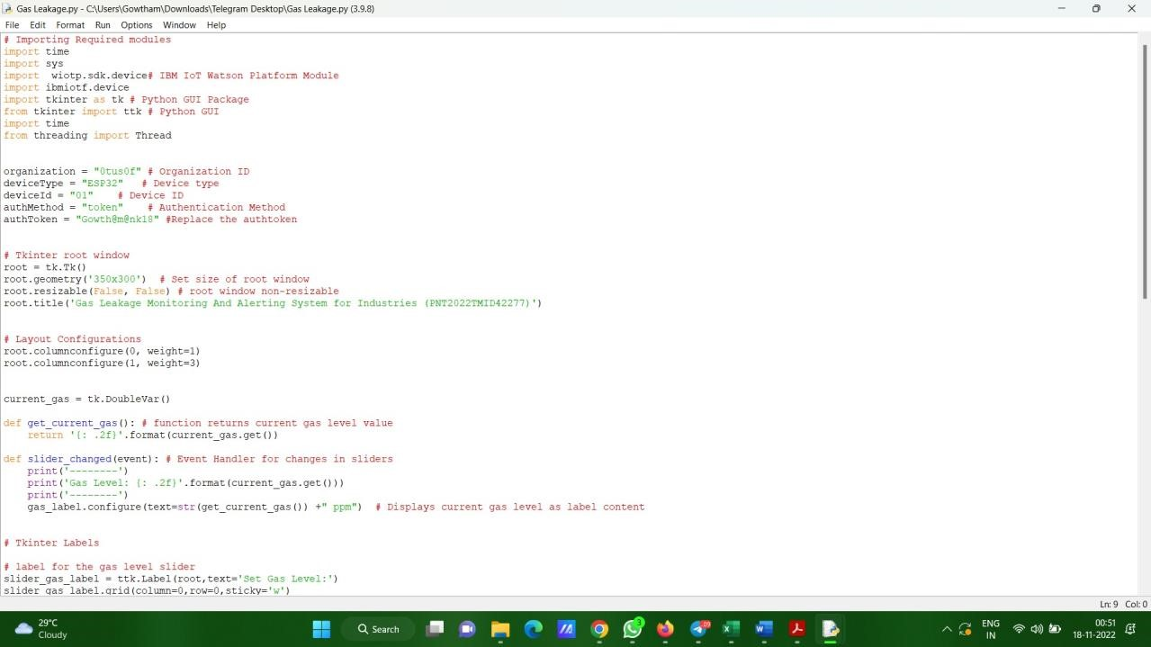

**OUTPUT:**

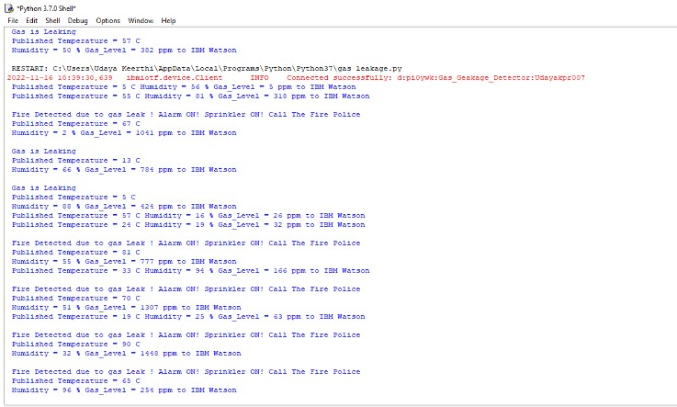

1. **Testing:**

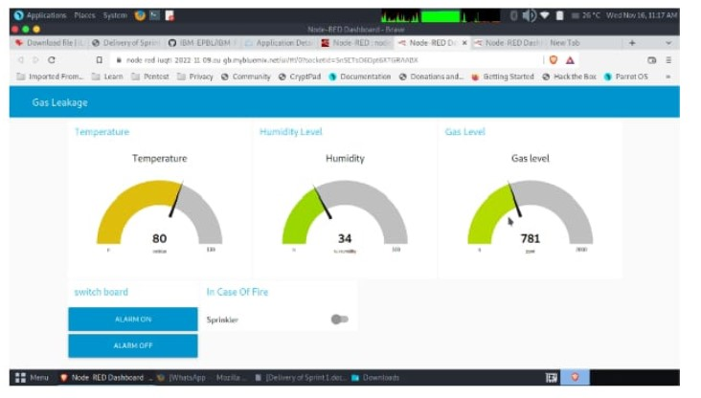

1. **Result:**

The system can be taken as a small attempt in connecting the existing primary gas detection methods to a mobile platform integrated with IoT platforms. The gases are sensed in an area of 1m radius of the rover and the sensor output data are continuously transferred to the local server. The accuracy of sensors is not up to the mark thus stray gases are also detected which creates an amount of error in the outputs of the sensors, especially in case of methane. Further the availability and storage of toxic gases like hydrogen sulphide also creates problems for testing the assembled hardware. As the system operates outside the pipeline, the complication of system maintenance and material selection of the system in case of corrosive gases is reduced. Thus, the system at this stage can only be use data primary indicator of leakage inside a plant.

1. **Advantages/Disadvantages:**

**10.1 Advantages:**

1. Get real-time alerts about the gaseous presence in the atmosphere.
2. Prevent fire hazards and explosions.
3. Supervise gas concentration levels.
4. Ensure worker’s health.
5. Real-time updates about leakages.
6. Cost-effective installation.
7. Data analytics for improved decisions.
8. Measure oxygen level accuracy.
9. Get immediate gas leak alerts.

**10.2 Disadvantages:**

1. It requires air or oxygen to work.
2. It gets reacted due to heating of wire.
3. It can be poisoned by lead, chlorine and silicon
   * 1. **CONCLUSION:**

This gas leak detector system contains two features, this includes the SMS Gateway feature for only sending warning information regarding the gas leak to user, and the alarm for the warning alert. There is some improvement which can be applied for the future work, such as regarding the SMS Gateway, it need to enhance with feature such as notifying the user whenever the remaining credit balance is insufficient. Another thing which can be enhanced is regarding the sensor, the sensors in this module do not include somewhat notification for notifying the user whenever the sensor not working properly or not connected to the micro-controller for some cases, therefore, it is recommended to add this kind of features in the future work for better refinement.

* + 1. **FUTURE SCOPE:**

We propose to build the system using an MQ6 gas detection sensor and interface it with an Aurdino Uno microcontroller along with an LCD Display. This system uses the gas sensor to detect any gas leakages. The gas sensor sends out a signal to the microcontroller as soon as it encounters a gas leakage. The microcontroller processes this signal and a message is displayed on the LCD to alert the user.

* + 1. **APPENDIX:**
  1. **Circuit Diagram:**

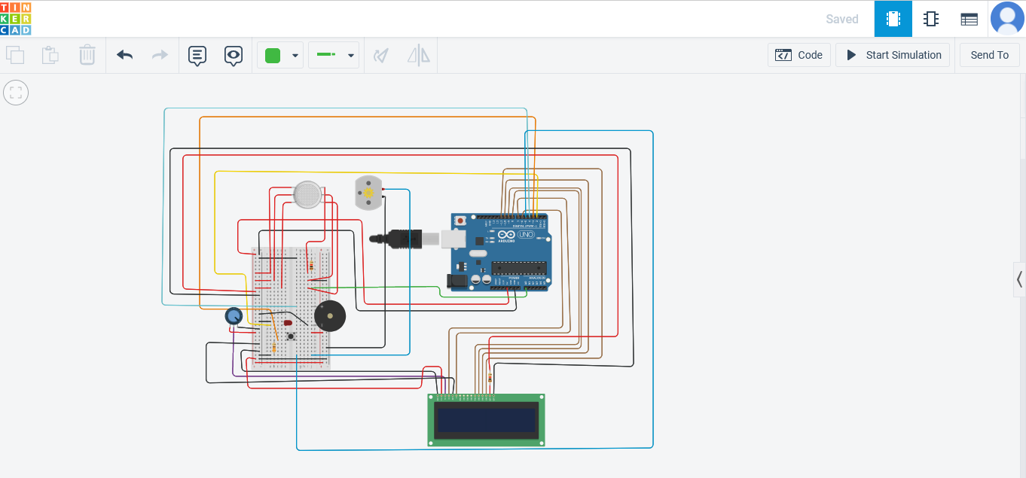

* 1. **Components:**

The design of a sensor-based automatic gas leakage detector with an alert and control

system. The components are

|  |  |  |
| --- | --- | --- |
| S.NO | NAME OF THE COMPONENT | QUANTITY |
| 1 | Arduino Uno R3 | 1 |
| 2 | LCD 16x2 | 1 |
| 3 | Piezo | 1 |
| 4 | Gas sensor | 1 |
| 5 | 1 k ohm Resistor | 1 |
| 6 | 2.3 k ohm Resistor | 1 |
| 7 | 4.7 k ohm Resistor | 1 |
| 8 | Red LED | 1 |
| 9 | Green LED | 1 |

**13.4 Source Code:**

#include <LiquidCrystal.h>

LiquidCrystal lcd(5,6,8,9,10,11);

int redled = A5; int greenled = A3; int buzzer = 4; int sensor = A0; int sensorThresh = 400; void setup()

{

pinMode(redled, OUTPUT); pinMode(greenled,OUTPUT); pinMode(buzzer,OUTPUT); pinMode(sensor,INPUT);

Serial.begin(9600);

lcd.begin(16,2);

}

void loop()

{

int analogValue = analogRead(sensor); Serial.println(analogValue); if(analogValue>sensorThresh)

{

digitalWrite(redled,HIGH); digitalWrite(greenled,LOW); tone(buzzer,1000,10000); lcd.clear(); lcd.setCursor(0,1); lcd.print("ALERT"); Serial.print("ALERT"); delay(1000); lcd.clear(); lcd.setCursor(0,1); lcd.print("EVACUATE"); Serial.println(" -- EVACUATE"); delay(1000);

}

else

{

digitalWrite(greenled,HIGH); digitalWrite(redled,LOW); noTone(buzzer); lcd.clear(); lcd.setCursor(0,0); lcd.print("SAFE"); Serial.print("SAFE"); delay(1000); lcd.clear(); lcd.setCursor(0,1); lcd.print("ALL CLEAR"); Serial.println(" -- ALL CLEAR"); delay(1000);

}

}

**13.5 GITHUB:**

**Link : h t t p s : / / g i t h u b . c o m / I B M - E P B L / I B M - P r o j e c t -**

**2 4 4 4 0 - 1 6 5 9 9 4 2 9 0 3**

**13.6 Demo Video:**

**LiNK: https://youtu.be/Eqz5v_VvZKQ**